RICH K-MEANS REPORT DUMP

# Kaggle Data

All genres, no normalization, no PCA

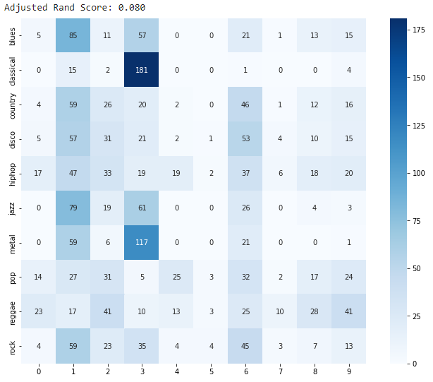

All genres, Normalization, no PCA

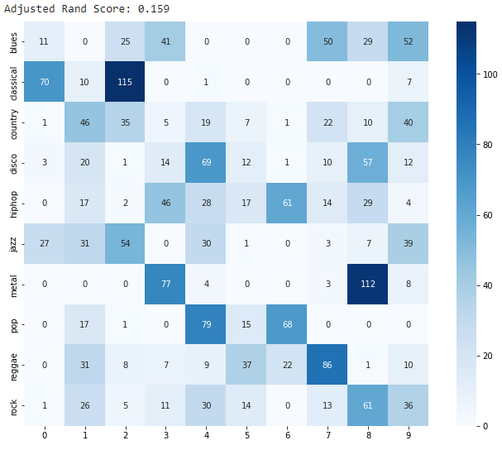

All genres, Normalization, PCA = 5

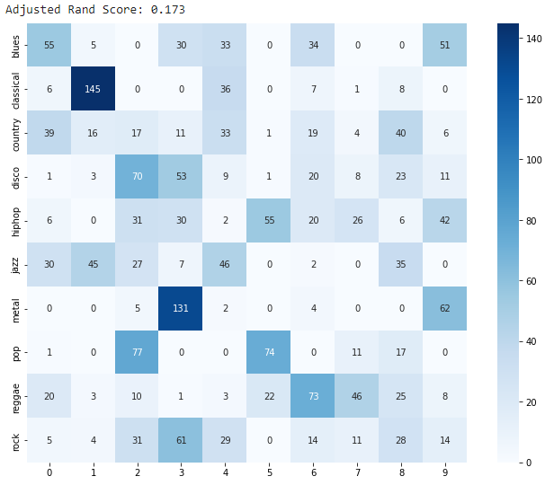0.17

All genres, Normalization, PCA = 10

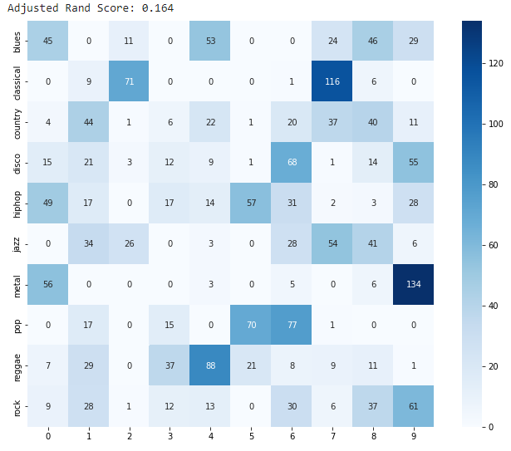

No blues, country, PCA = 5

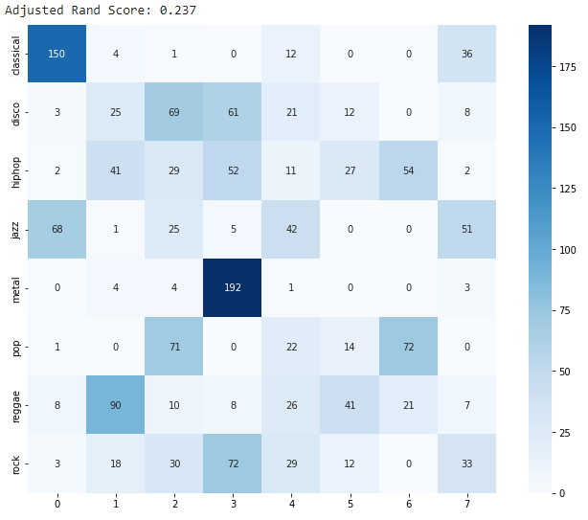

No blues, country, hip hop, PCA = 10

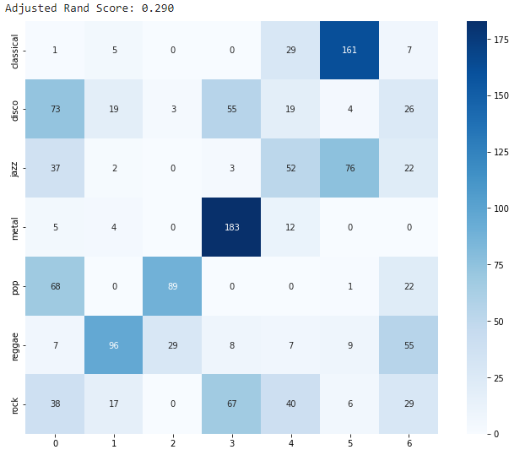

No blues, country, hip hop, jazz, PCA = 10

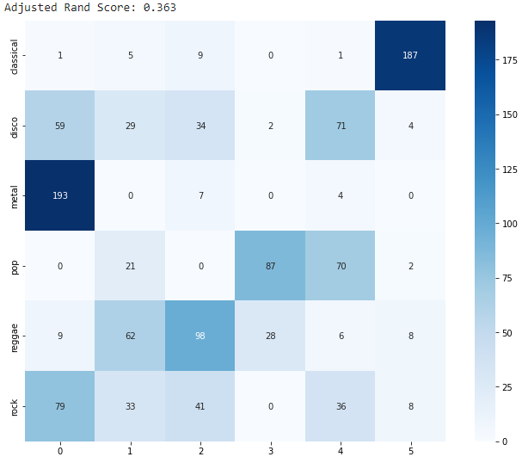

No blues, country, hip hop, jazz, rock PCA = 10

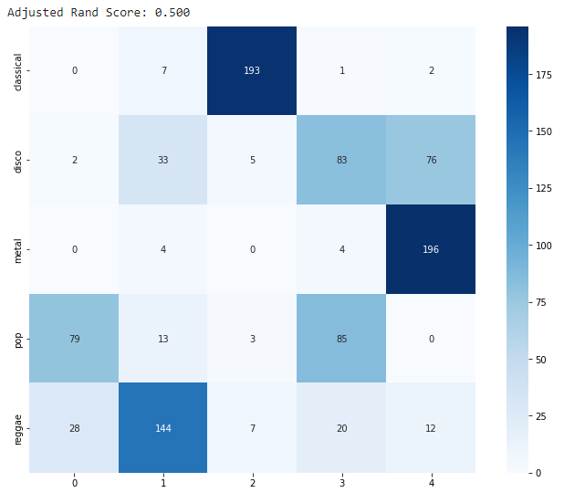

Classic, Metal, Disco, Reggae, PCA=15

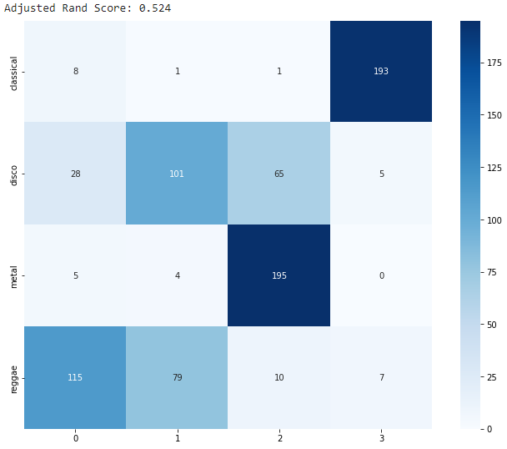

Classical, Metal, Reggae, PCA = 10

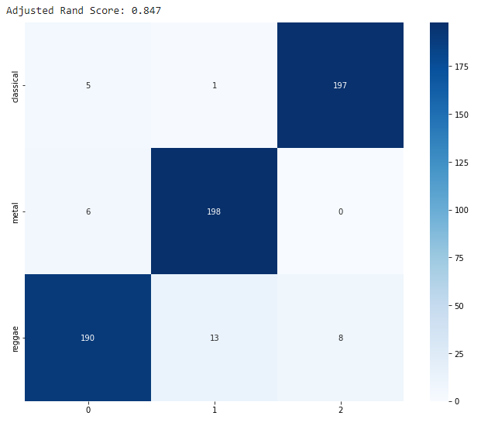

FBANKS

All genres, Normalize, PCA = 200

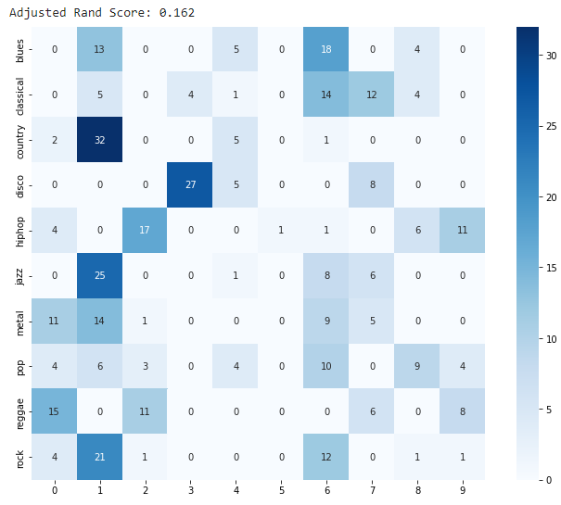

no county, blues Normalize, PCA = 100

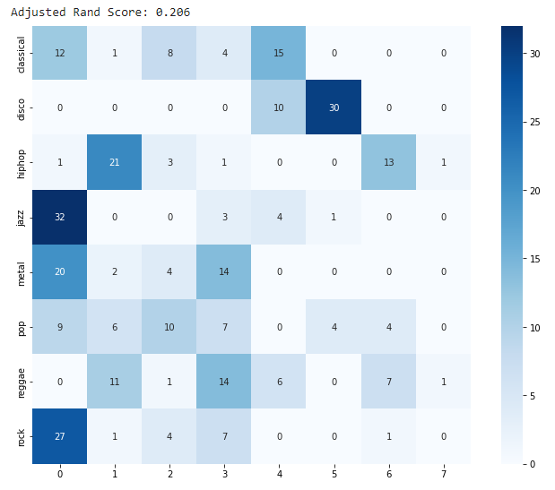

no county, blues, hip hop Normalize, PCA = 200

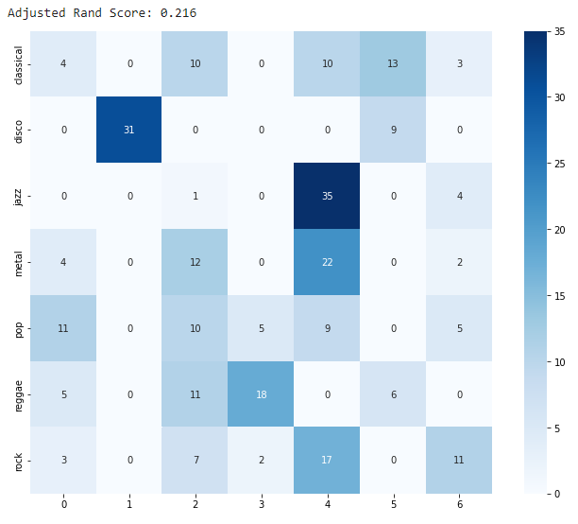

No blues, country, hip hop, jazz, PCA = 200

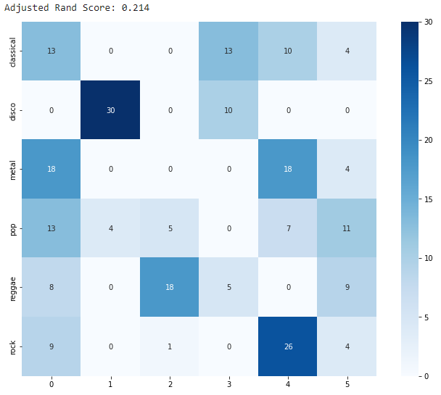

No blues, country, hip hop, jazz, rock PCA = 200

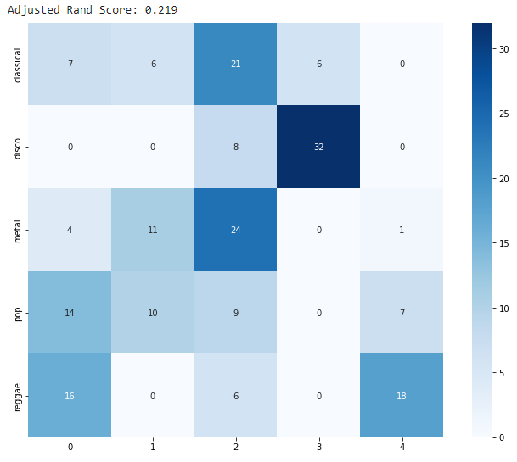

Classic, Metal, Disco, Reggae, PCA=200

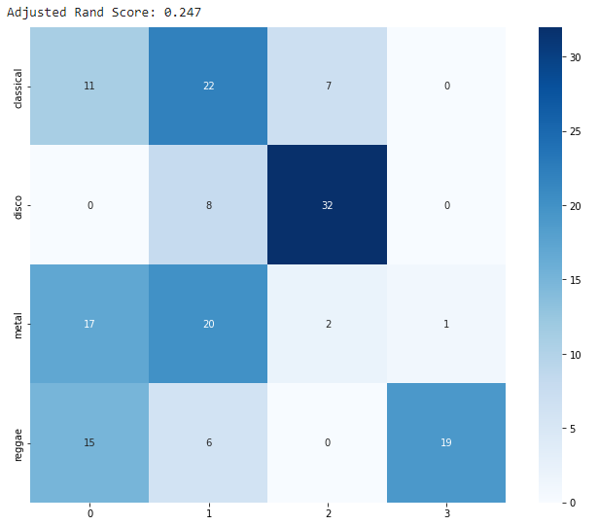

Classical, metal, reggae PCA 200

